**Student Council Mission:** To serve our school and community to make McCombs the number one school.

Hello students and staff! This is the McCombs newspaper written by Student Council. In the upcoming papers we will be including sport schedules, students of the month, upcoming events, stories, comics, surveys, and much more! The newspaper will be distributed every month by Student Council officers! Have a good 2017 - 2018 school year! ☺

**Meet our Student Council Officers:**

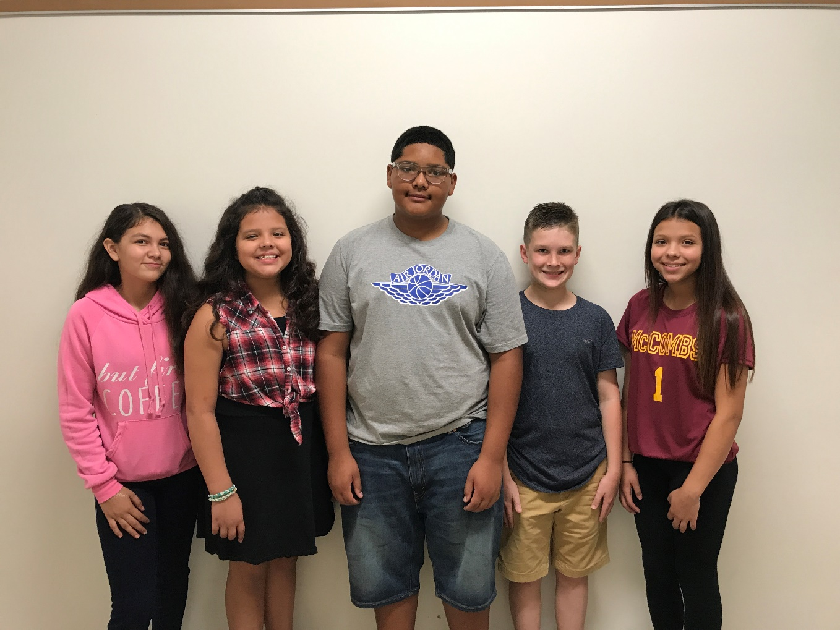

V. Pres. – Maria Santos, Pres. – Sophia Gonzalez, Sec. – Israel Smith, Treas. – Hank Schroeder,and Par. - Angelica Gonzalez

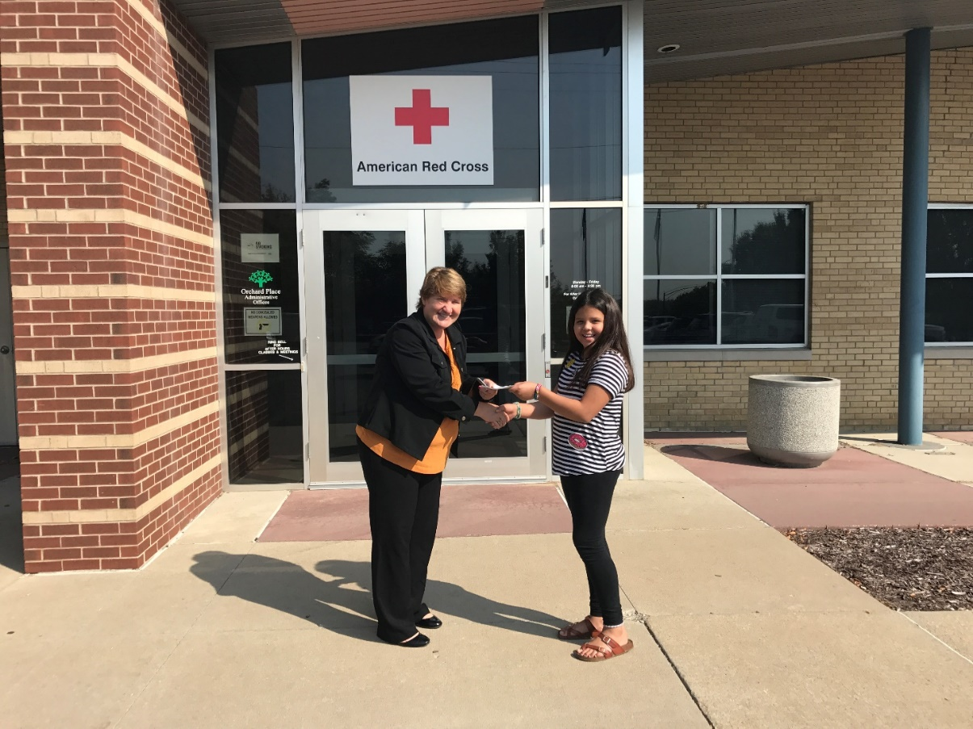

President Sophia Gonzalez handing a check to the American Red Cross to help the victims of Hurricane Harvey

**Golden Eagles:** Do you want to be a part of the largest organization at McCombs? The Golden Eagle pledge window will run from September 18th through October 2nd. You can pick up a packet from one of your grade level teachers.

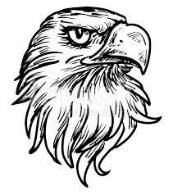

**Volleyball Schedule:** ALL GAMES START @ 3:00PM

September 14th – 8th grade McCombs vs. Merrill @ McCombs

September 18th – 7th grade McCombs vs. Merrill @ Merrill

September 21st – 8th grade McCombs vs. Meredith @ Meredith

September 23rd – Winterset Tournament @ 8:00am

September 25th – 7th grade McCombs vs. Meredith @ McCombs

September 28th – 8th grade McCombs vs. Harding @ Harding

September 30th – 7th grade City Tournament @ Lincoln HS @ 9:00am

October 2nd – 7th grade McCombs vs. Harding @ McCombs

October 5th – 8th grade McCombs vs. Hoyt @ McCombs

October 7th – 8th grade City Tournament @ East HS @ 8:00am

October 9th – 7th grade McCombs vs. Callanan @ McCombs

October 10th – 8th grade McCombs vs. Callanan @ Callanan

**Cross Country Schedule:**

September 14th – Lincoln @ Ewing Park @ 4:00pm

September 21st – Lincoln @ Indianola MS 4:00pm

September 25th - All schools @ Legacy Point Park @ 4:30pm

October 5th - All schools @ Ewing Park @ 4:00pm

October 10th - All schools @ SE Polk High School @ 4:00pm

**Football Schedule:**

September 19th - Lincoln vs. Roosevelt @ North High School @ 4:30pm

September 26th - Lincoln vs. Ankeny @ Lincoln High School @ 4:30pm

October 3rd - Lincoln vs. North @ North High School @ 4:30pm

October 10th - Lincoln vs. Hoover @ Hoover High School @ 4:30pm

October 17th - Lincoln vs. Dowling @ Lincoln High School @ 4:30pm