Announcing McCombs’s 2016-17
Official “Non-Fundraiser”
Sponsored by
The McCombs Middle School Booster Club
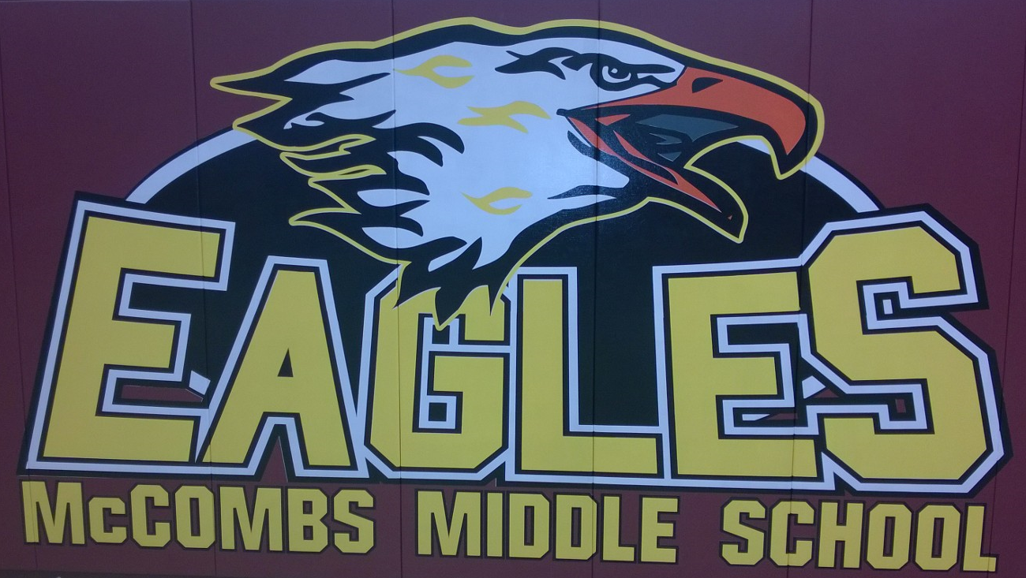

Dear McCombs Community,
Have you ever thought to yourself, “I would love to help fund our school programs, but I don’t want to fundraise?” Well, this is the program for you!
This is our “non-event” for 2016-2017. No hassles, 100% tax-deductible and you don’t even have to leave your home. You may choose to participate in this program in lieu of other fundraising activities or in addition to them.
The Booster Club is organized to enhance and support the educational experience at McCombs Middle School by developing a closer connection between the school and home. We encourage parent involvement and seek to improve the learning environment at McCombs Middle School.
In order to reach our goals, we need to raise approximately $5.00 per student. Money raised by the Booster Club goes toward funding the Assessment Incentives and other needs McCombs School may request.
Please consider participating on a level where you feel comfortable.
_______ | I only want to get out of a little work. Hope my $5.00 helps. ☺
_______ | Because I don’t have the time or energy to rearrange my cupboards and closets to store all that wrapping paper, I’ll donate $10.00. ☺ ☺
_______ | My thighs insist that I give a donation of $15.00 for not subjecting them to selling (and eating) cookie dough. ☺ ☺ ☺
_______ | On behalf of my friends, who don’t want to have to go into hiding to avoid my sales pitch, I’m donating $20.00. ☺ ☺ ☺ ☺
_______ | I didn’t help last year and I feel very guilty about it. In fact, I don’t plan on helping this year either. So here is $25.00 to forget my name until 2018. ☺ ☺ ☺ ☺ ☺
_______ | Please accept the enclosed donation of $_____ with my thanks and appreciation for everything the Booster Club does for McCombs Middle School teachers and students. ☺

Your generosity is greatly appreciated! We thank you for supporting the Booster Club’s efforts to make McCombs Middle School a quality school for all of our students.
Please place this form and your donation in an envelope marked “McCombs Boosters Donation”. Ask your student to give it to his/her Homeroom Teacher by Friday, October 14.
Please Make Checks Payable to “McCombs Middle School Boosters”
The Homeroom classroom with the highest participation rate, earns a pizza party!

