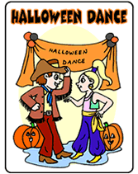 McCombs Middle School Dance 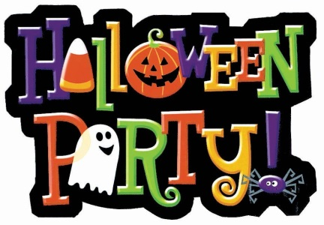

What: School Dance
Where: Gym
When: Oct. 31st
Time: 2:45pm-4:15pm
Who: Everyone except students with two or more level 2’s, a level 3 or any un-served detentions starting on Oct. 14th.
Cost: $3.00 dollars for students, or $5.00 dollars if you have a level 2 starting Oct. 14th.

